Vakantie Kroatië

Airbnb
https://www.anb.nl/login?redirect_params[action]=dashboard&redirect_params[controller]=homeirb
Login Airbnb: grdroo@gmail.com + geroom1611

Plaats: Razanj, Kroatië
appartement 'village-6 € 53,= per dag -/- 20%
Zoekstring airbnb: Rogoznica, Kroatië of Razanj, Kroatië
Verhuurder: Simona, Villa Mona

vakantieperiode: ma 19 mei >> wo28 mei

==============================================
Reisschema
Bevestigingscode: JJE3RR

Uw verhuurder
Simona Horvat
Mezaroca-Dražica bb Ražanj, Rogoznica, Dalmatia 22203, Kroatië
+385 98 922 3331
email: simona.3107@gmail.com

Routebeschrijving
Trip directions: I’m not sure on which board are you entering the country, but you will probably driving on highway in the direction of Šibenik, Split. Disconnect from the highway on the exit Šibenik, Primošten. When you drive from the direction of Šibenik, you have to pass town Primošten and Rogoznica. After that you have to look up for sign Ražanj, Dvornice and turn right. Follows the direction for Ražanj and then you will come to the turn for the first bay called Kalebova luka but you pass it as same as the second one called Ljoljinica. The third turning is our bay Mezaroca. When you come into Mezaroca turn left on first crossroads, it would seem like you are going downhill to the sea (and you are). In the middle of this street is our house, big white one.

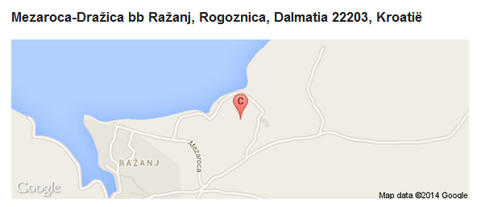

==============================================
(01-04-2014) Dear Simona,
Airbnb accepted my reservation and I received the bill already. So I believe all the problems are solved for now. Only the directions I received will give me probably some trouble.
Hereby I send you a picture of your living area. If you can, will you be so kind to mark the part of your house and send me the picture back. Or make a marked scan and send me that picture. (perhaps an idea to put that picture on the Airbvb-site too.) That will make finding your place very very easy.
Many thanks for your help and we will meet soon.
Cheers,
Gerard Roomer
Phone: +316 53 220 221

(31-03-2014) Dear Simona,
I informed Airbnb with my reservation and they have my creditcard information now. I want to pay the whole amount.
Cheers, Gerard

(31-03-2014) Dear Gerard,
If you want confirmation you have to pay throught Airbnb, I will send you a special offer immediately. Would you like to pay a whole amount (with discount) now or you would prefer to pay 30% of amount now and the rest when you arrived?
Best wishes,
Simona

(31-03-2014) Dear Simona,
Herewith we confirm our request for village-6 for the mentioned period. The flight is booked. So we will arrive mai 19th somewhere in the afternoon.
Do I have to book via airbnb or do you inform Airbnb and will I receive an confirmation via them?
We look forward to meet you next month
Cheers
Gerard Roomer

Verzonden vanaf mijn LG Tablet


Simona10:26

(30-03-2014) Hi Gerard,
No, everything is ok, it is only important that there would be any missunderstandings. I will give you the same 20% discount for these apartment and I see that you now changed the dates, is it ok? Can you please write me the dates you want and I will send you a special offer with the price 20% lower than this showen one.
Best wishes,
Simona

------------

Dear Simona, We liked and follow your advise... Are these dates free and do we get some discount too? Sorry for de false emails and all the time you had to spent on us. Cheers, Gerard Roomer

